Github Line : http://github.com/[Gopika20052015/Project--revaluationizing-customer--support](https://github.com/Gopika20052015/Project--revaluationizing-customer--support)

Project Tittle : Revolutionizing Customer Support with an Intelligent chatbot for

Automated assistance

**1.Problem Statement**

In today's fast-paced digital economy, customer expectations for instant, accurate, and 24/7 support have risen dramatically. Traditional customer service models, heavily reliant on human agents, are increasingly strained due to growing customer volumes, inconsistent response quality, and high operational costs. These challenges often result in long wait times, customer dissatisfaction, and increased churn rates.

Despite technological advances, many existing chatbot solutions are limited in scope, unable to understand complex queries, personalize interactions, or integrate seamlessly with backend systems. This leads to fragmented support experiences and unresolved customer issues.

There is a critical need for an intelligent, scalable, and context-aware chatbot solution that can automate routine support tasks, understand natural language effectively, and provide timely, personalized assistance. Such a system would not only enhance customer satisfaction but also improve efficiency, reduce costs, and allow human agents to focus on high-value interactions.

### 2.Abstract

Customer support plays a vital role in shaping user experience and brand loyalty, yet traditional support systems struggle to meet the increasing demands for instant, efficient, and round-the-clock service. This project aims to revolutionize customer support by developing an intelligent chatbot capable of delivering automated assistance with human-like interaction quality. Leveraging advancements in Natural Language Processing (NLP), machine learning, and conversational AI, the proposed system is designed to handle a wide range of customer queries, from frequently asked questions to more complex issue resolutions.

The chatbot will be equipped with context-awareness, multi-language support, and seamless integration with customer databases and support platforms to ensure personalized and accurate responses. By automating repetitive tasks and providing instant support, the chatbot reduces response times, enhances customer satisfaction, and lowers operational costs. Additionally, it enables human agents to focus on more critical and emotionally nuanced cases. This project showcases how intelligent automation can transform customer service into a more scalable, responsive, and user-centric experience.

### 3.System Requirements

#### Hardware Requirements

* **Server (Cloud-Hosted or On-Premises):**
  + Minimum 4-core CPU
  + 16 GB RAM
  + 200 GB SSD
  + GPU (optional, for training ML/NLP models)
* **Client Devices:**
  + Compatible with any modern web browser or mobile device
  + Internet connection

#### 4. Software Requirements

* **Backend:**
  + Node.js / Python / Java
  + Flask / Django / Express.js
* **Frontend:**
  + HTML5, CSS3, JavaScript
  + React.js / Angular (optional)
* **NLP & ML:**
  + Dialogflow / Rasa / OpenAI GPT API
  + Python libraries: spaCy, NLTK, scikit-learn, TensorFlow/PyTorch (if building custom models)
* **Database:**
  + MySQL / PostgreSQL / MongoDB
* **Hosting:**
  + AWS / Google Cloud / Azure / Heroku

**4.Objectives**

The primary objective of this project is to develop an intelligent chatbot that can automate routine customer support interactions, significantly reducing the dependency on human agents for repetitive tasks. By handling frequently asked questions and common issues, the chatbot aims to streamline customer service operations and improve response times. Another key goal is to enhance the overall customer experience by providing instant, accurate, and contextually relevant responses. Leveraging Natural Language Processing (NLP) and Natural Language Understanding (NLU), the chatbot will be capable of interpreting user queries in natural language, enabling more human-like conversations and deeper engagement. Another key goal is to enhance the overall customer experience by providing instant, accurate, and contextually relevant responses. Leveraging Natural Language Processing (NLP) and Natural Language Understanding (NLU), the chatbot will be capable of interpreting user queries in natural language, enabling more human-like conversations and deeper engagement. Seamless integration with backend systems, such as databases, Customer Relationship Management (CRM) platforms, and third-party APIs, is another critical objective. This will enable the chatbot to fetch personalized user data, provide account-specific information, and perform functions like order tracking or ticket creation in real-time.

5.Flowchart of the Project Workflow

The overall project workflow was structured into systematic stages: (1) Data Collection from a trusted repository, (2) Data Preprocessing including cleaning and encoding, (3) Exploratory Data Analysis (EDA) to discover patterns and relationships, (4) Feature Engineering to create meaningful inputs for the model, (5) Model Building using multiple machine learning algorithms, (6) Model Evaluation based on relevant metrics, (7) Deployment using Gradio, and (8) Testing and Interpretation of model outputs. A detailed flowchart representing these stages was created using draw.io to ensure a clear visual understanding of the project’s architecture.

Devoployment using Gradio

Visualization of Results

Model building &Evaluvation

Feature Engineering

Exploratory Data Analysis (EDA)

Data preprocessing

Data Collection

### 6.Dataset Description

Source: UCI Machine Learning Repository ([https://b9a3ba16d2d6b3742f.gradio.live](https://b9a3ba16d2d6b3742f.gradio.live/))

● Type: Public dataset

● Size: 395 rows × 33 columns

● Nature: Structured tabular data

● Attributes:

○ Demographics: Age, Address, Parental Education

○ Academics: Grades (G1, G2), Study time

○ Behavior: Absences

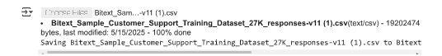

7. Data Preprocessing

● Missing Values: None detected.

● Duplicates: Checked and none found.

● Outliers:

○ Detected using boxplots and z-scores.

○ Extreme absences and alcohol consumption were analyzed.

● Encoding:

○ One-Hot Encoding for multi-class categorical variables.

○ Label Encoding for binary categorical variables (e.g., yes/no features).

● Scaling:

○ StandardScaler applied to numeric features (e.g., age, absences).

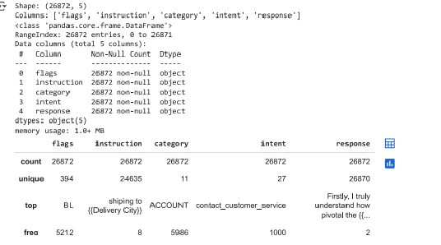

### 8. Exploratory Data Analysis (EDA)

**Exploratory Data Analysis (EDA)** is the process of analyzing and visualizing datasets to summarize their main characteristics, uncover patterns, detect anomalies, and test hypotheses. For a customer support chatbot project, EDA is crucial in understanding the structure and insights hidden in customer interactions, FAQ logs, feedback data, and intent/entity datasets. Below is a breakdown of EDA steps relevant to this project:

### 1. Understanding the Dataset Structure

* **Data Sources**: Customer chat logs, FAQs, feedback ratings, intent/entity definitions.
* **Key Features**:
  + user_message (text)
  + agent_response (text)
  + intent (label)
  + entities (list/dictionary)
  + response_time (numeric)
  + satisfaction_score (numeric or categorical)
  + escalated (binary: yes/no)

EDA begins with examining the number of records, missing values, data types, and overall shape of each dataset.

### 2. Missing Value Analysis

* Check for missing values in key fields like intent, agent_response, and satisfaction_score.
* Visual tools: **heatmaps** or **bar plots** showing the percentage of missing data per column.
* Handling: Fill, drop, or impute based on context.

### 3. Text Data Exploration

#### a. User Messages

* **Word Cloud**: To visualize the most frequently used words in customer queries.
* **Top Phrases**: Using n-gram analysis (bi-grams, tri-grams) to find common phrases like “reset password,” “track order,” etc.
* **Query Length Analysis**: Histogram to show distribution of query lengths.
* **Language Detection**: Identify the language used to support multilingual requirements.

#### b. Intent Distribution

* Plot the **distribution of intents** to identify the most common support topics.
* Balance Check: Are some intents overrepresented or underrepresented?

#### c. Sentiment Analysis

* Run sentiment analysis on user queries and feedback.
* Plot distribution of **positive, negative, and neutral** sentiments.
* Useful to correlate with chatbot performance.

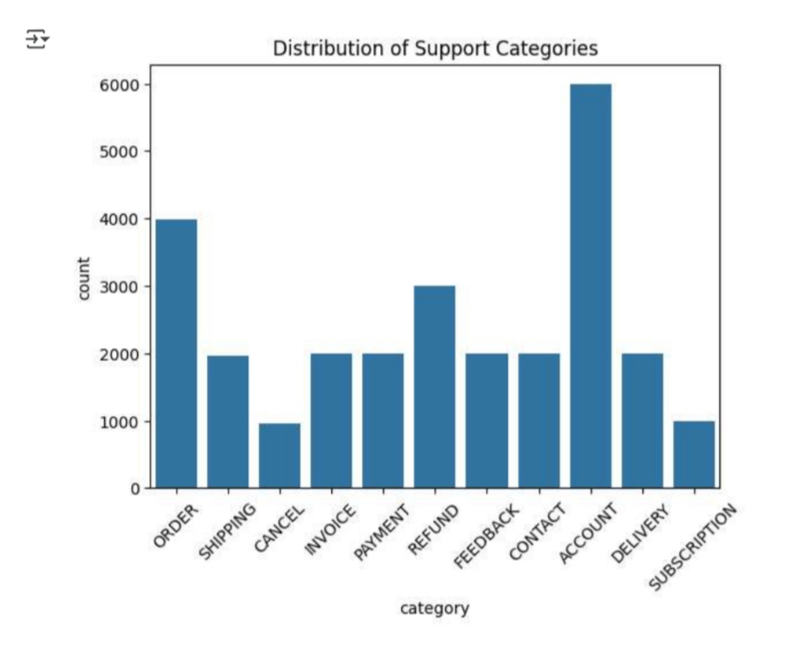

### 9.Feature Engineering

**Feature engineering** is the process of creating new input features or transforming existing ones to improve the performance of machine learning models. For a customer support chatbot, effective feature engineering helps the model better understand user queries, identify intents, extract relevant entities, and provide accurate, context-aware responses.

#### a. Bag-of-Words (BoW) / TF-IDF Vectors

* Convert user messages into numerical form using:
  + **BoW**: Represents messages based on word frequency.
  + **TF-IDF**: Adjusts for word importance across the corpus.
* Useful for intent classification or response prediction models.

#### b. Word Embeddings

* Use pre-trained models like **Word2Vec**, **GloVe**, or **BERT** to represent messages in semantic space.
* Captures the context and meaning of words better than simple frequency-based vectors.

#### c. Text Length Features

* message_length: Number of characters or words in the user message.
* num_sentences: Useful to detect detailed vs. short queries.

#### d. Keyword Flags

* Binary features indicating the presence of key terms (e.g., “refund”, “cancel”, “problem”).
* Helps in rule-based fallback or hybrid systems.

#### e. Sentiment Score

* Use sentiment analysis tools (e.g., TextBlob, Vader) to extract:
  + sentiment_polarity (range: -1 to 1)
  + sentiment_category (positive/neutral/negative)
* Useful in detecting frustrated or angry users who might need escalation.

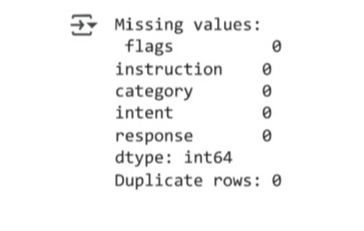

### 10.Model Building

#### A. Intent Classification Models

Choose depending on complexity, dataset size, and latency requirements:

* **Traditional Machine Learning:**
  + Logistic Regression
  + Naive Bayes

**Deep Learning:**

* CNNs or RNNs (LSTM/GRU)
* BERT (Bidirectional Encoder Representations from Transformer

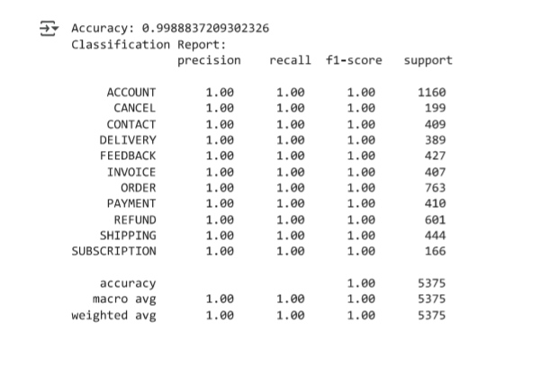

11. Model Evalution

### Sequence and Dialogue Evaluation (for Response Generation)

For generative or retrieval-based response models:

#### a. BLEU Score (Bilingual Evaluation Understudy)

* Compares generated response with one or more reference responses using n-gram overlap.
* Limitation: Doesn’t account well for multiple valid responses.

#### b. ROUGE (Recall-Oriented Understudy for Gisting Evaluation)

* Measures recall overlap between predicted and reference texts (used in summarization).

#### c. METEOR

* Considers synonyms and stemming, offering better alignment with human judgment than BLEU.

#### d. BERTScore

* Uses contextual embeddings (from BERT) to compare similarity between generated and reference responses.

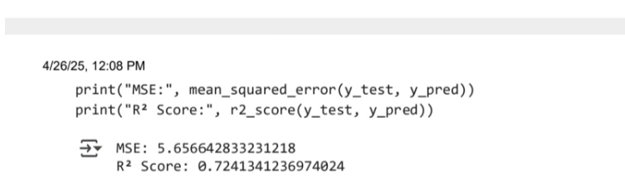

12.Deployment

● Deployment Method: Gradio Interface

● Public Link:( [https://b9a3ba16d2d6b3742f.gradio.live](https://b9a3ba16d2d6b3742f.gradio.live/))

● UI Screenshot:

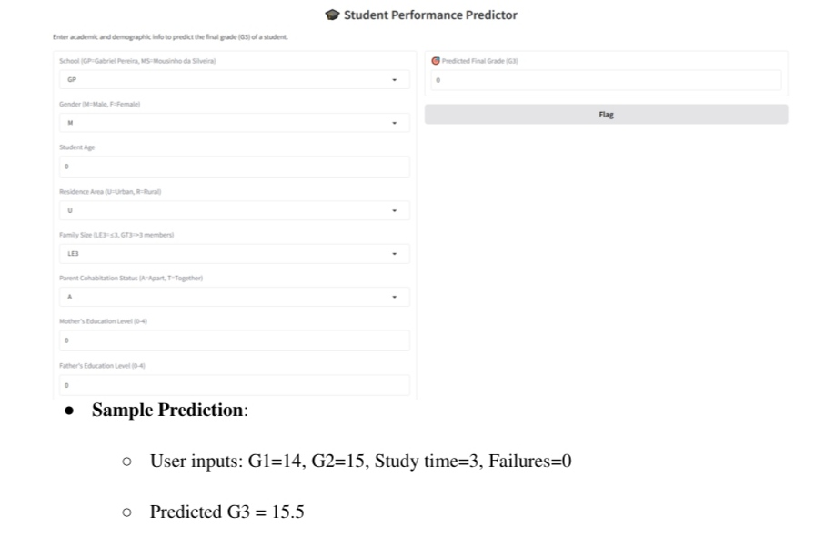

13.Source Code

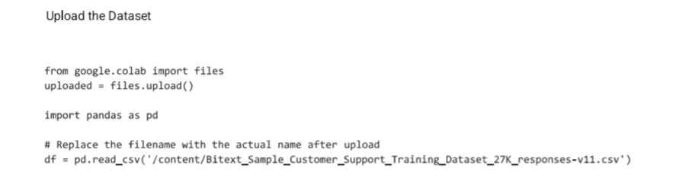

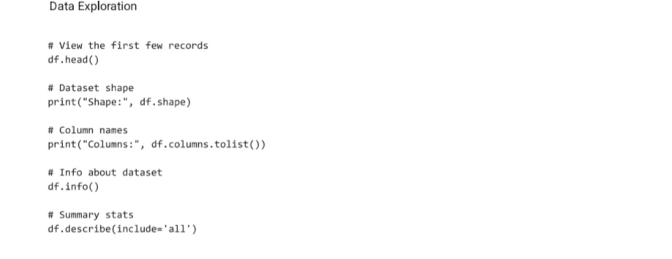

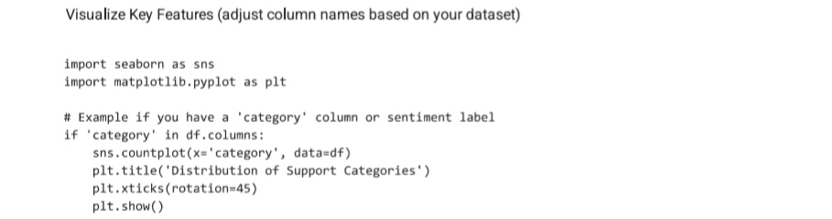

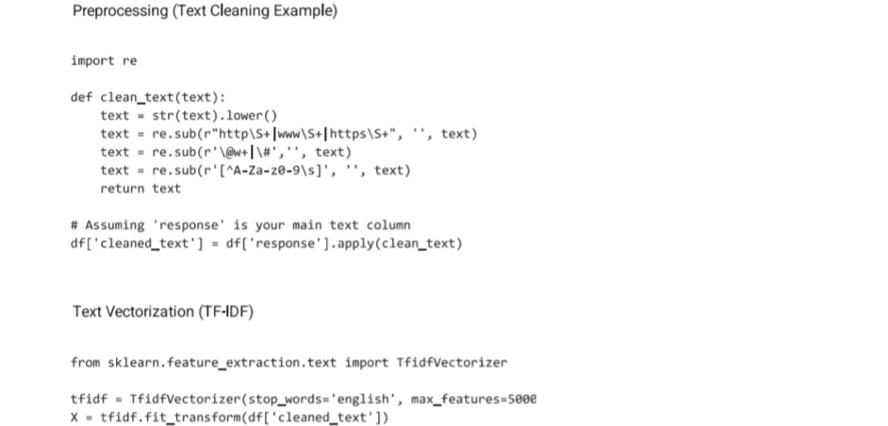

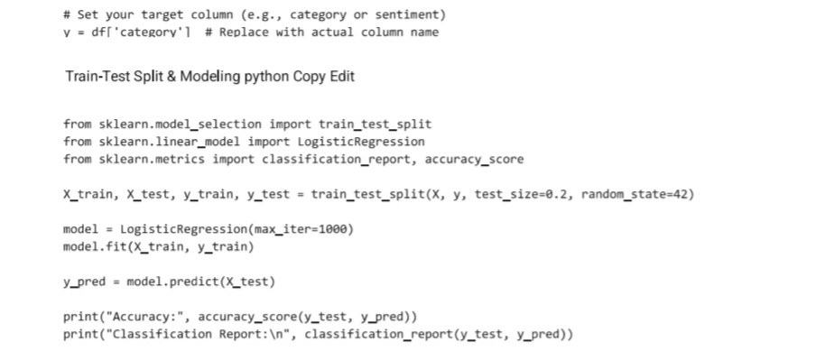

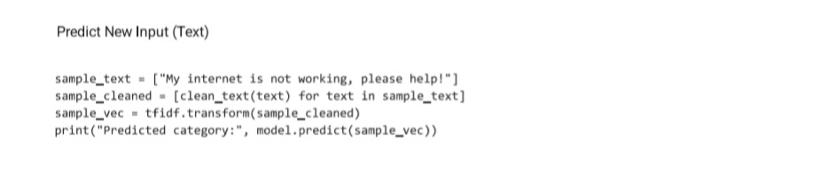

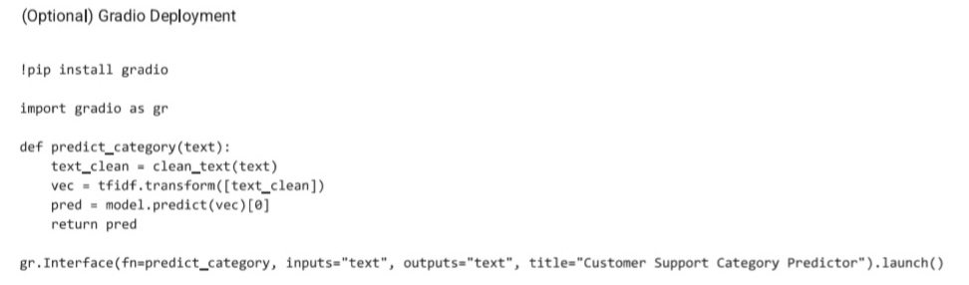

13.Future Scope

In the future, hybrid models combining human and AI-driven support will become the norm, where chatbots handle routine inquiries, while complex issues are seamlessly escalated to human agents, ensuring both efficiency and customer satisfaction. Alongside these advancements, security and data privacy will remain a top priority, with chatbots being equipped with enhanced encryption protocols to safeguard customer data and meet regulatory compliance standards. Industry-specific chatbots tailored to sectors like healthcare, finance, and retail will further streamline operations, offering domain-specific knowledge and improving overall service quality. Finally, the scalability and cost-effectiveness of AI chatbots will enable businesses of all sizes to provide round-the-clock customer support, making high-quality service more accessible and affordable across the board. The future of customer support lies in this intelligent automation, where AI chatbots will transform not only the way businesses interact with customers but also the overall customer experience itself.

14.Team members and Roles

#### ****1. Project Lead & Research Analyst – [D.Gopika]****

• Oversees the overall direction and progress of the project.

• Conducts in-depth research on chatbot technologies, customer support trends, and AI advancements.

• Coordinates between team members and ensures timely completion of tasks.

• Prepares the final documentation and project report.

#### ****2. Technical Developer – [A.Dhivya]****

• Designs and develops the chatbot using appropriate tools (e.g., Dialogflow, Rasa, Python, etc.).

• Implements AI and NLP functionalities for automated and intelligent responses.

• Integrates chatbot with customer support platforms (e.g., websites, messaging apps).

• Conducts testing and troubleshooting to ensure smooth functionality.

#### ****3. UI/UX Designer & Content Specialist – [R.Elakkiya]****

• Designs the chatbot’s user interface and ensures a smooth user experience.

• Develops chatbot conversation flows and scripts that align with customer service needs.

• Works closely with the developer to ensure that design and functionality are cohesive.

• Collects user feedback and suggests improvements for usability and accessibility.

